AI-Lab 09 Submission

Name: Yash Raj
Roll Number: 24k-0737

Task01:
Bayesian Network structure:
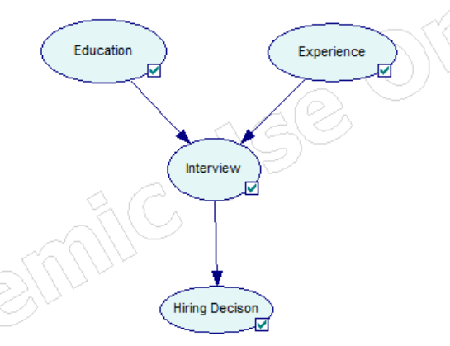
CPTs:
Education:
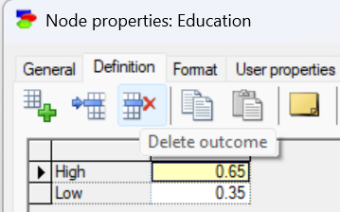
Experience:
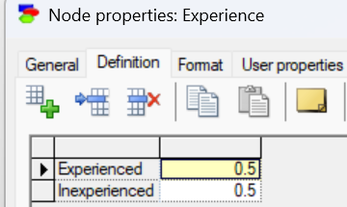
Interview:
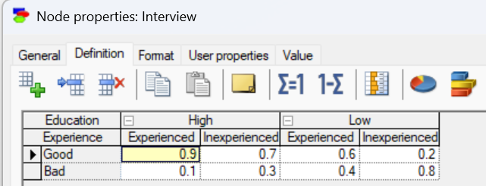
Hiring Decision:
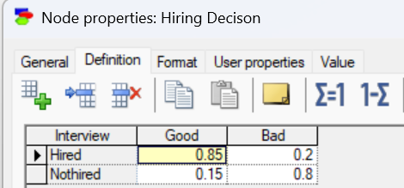

Code:
from pgmpy.models import BayesianNetwork
from pgmpy.factors.discrete import TabularCPD
from pgmpy.inference import VariableElimination

model = BayesianNetwork([
('Education', 'Interview'),
('Experience', 'Interview'),
('Interview', 'HiringDecision')
])
cpd_education = TabularCPD(
variable='Education',
variable_card=2,
values=[[0.65], [0.35]]
)
cpd_experience = TabularCPD(
variable='Experience',
variable_card=2,
values=[[0.5], [0.5]]
)

cpd_interview = TabularCPD(
variable='Interview',
variable_card=2,
values=[
[0.9, 0.7, 0.6, 0.2],
[0.1, 0.3, 0.4, 0.8]
],
evidence=['Education', 'Experience'],
evidence_card=[2, 2]
)
cpd_hiring = TabularCPD(
variable='HiringDecision',
variable_card=2,
values=[
[0.85, 0.2],
[0.15, 0.8]
],
evidence=['Interview'],
evidence_card=[2]
)
model.add_cpds(cpd_education, cpd_experience, cpd_interview, cpd_hiring)
print(model.check_model())
inference = VariableElimination(model)
result = inference.query(
variables=['HiringDecision'],
evidence={'Education': 0, 'Experience': 1}
)
print(result)
Task02:
Bayesian Network structure:
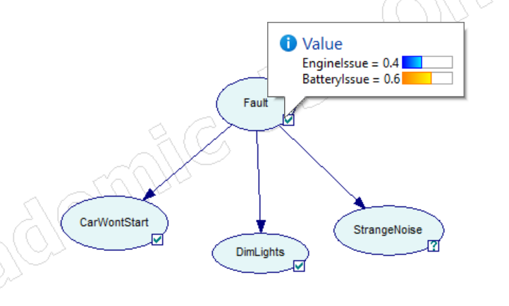
CPTs
Fault:
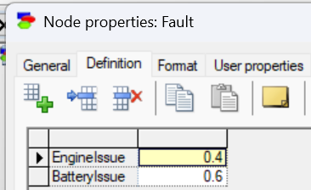

CarWontStart:
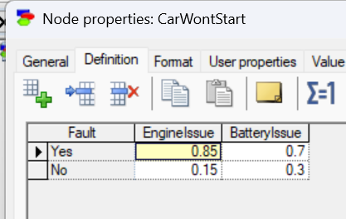

DimLights:
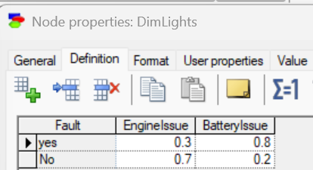
StrangeNoise:
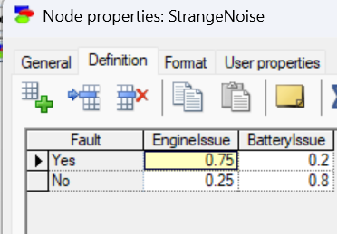
Code:
from pgmpy.models import BayesianNetwork
from pgmpy.factors.discrete import TabularCPD
from pgmpy.inference import VariableElimination
model = BayesianNetwork([
('Fault', 'CarWontStart'),
('Fault', 'DimLights'),
('Fault', 'StrangeNoise')
])
cpd_fault = TabularCPD(
variable='Fault',
variable_card=2,
values=[[0.4], [0.6]]
)
cpd_start = TabularCPD(
variable='CarWontStart',
variable_card=2,
values=[
[0.85, 0.7],
[0.15, 0.3]
],
evidence=['Fault'],
evidence_card=[2]
)
cpd_light = TabularCPD(
variable='DimLights',
variable_card=2,
values=[
[0.3, 0.8],
[0.7, 0.2]
],
evidence=['Fault'],
evidence_card=[2]
)
cpd_noise = TabularCPD(
variable='StrangeNoise',
variable_card=2,
values=[
[0.75, 0.2],
[0.25, 0.8]
],
evidence=['Fault'],
evidence_card=[2]
)
model.add_cpds(cpd_fault, cpd_start, cpd_light, cpd_noise)
print(model.check_model())
inference = VariableElimination(model)
result = inference.query(
variables=['Fault'],
evidence={
'CarWontStart': 0,
'DimLights': 0,
'StrangeNoise': 0
}
)
print(result)

Task03:
Bayesian Network structure:
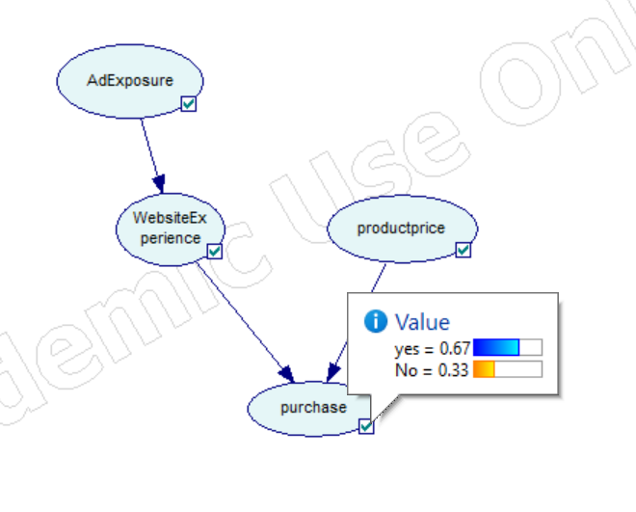
CPTs:
AdExposure:
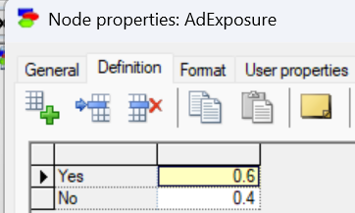

Website Experience:
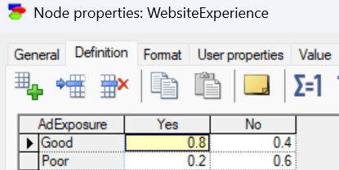

Product price:
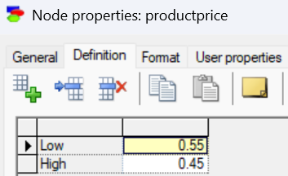
Purchase:
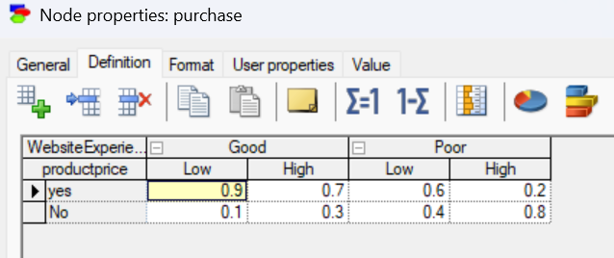

Code:
from pgmpy.models import BayesianNetwork
from pgmpy.factors.discrete import TabularCPD
from pgmpy.inference import VariableElimination

model = BayesianNetwork([
('AdExposure', 'WebsiteExperience'),
('WebsiteExperience', 'Purchase'),
('ProductPrice', 'Purchase')
])

cpd_ad = TabularCPD(
variable='AdExposure',
variable_card=2,
values=[[0.6], [0.4]]
)

cpd_website = TabularCPD(
variable='WebsiteExperience',
variable_card=2,
values=[
[0.8, 0.4],
[0.2, 0.6]
],
evidence=['AdExposure'],
evidence_card=[2]
)

cpd_price = TabularCPD(
variable='ProductPrice',
variable_card=2,
values=[[0.55], [0.45]]
)

cpd_purchase = TabularCPD(
variable='Purchase',
variable_card=2,
values=[
[0.9, 0.7, 0.6, 0.2],
[0.1, 0.3, 0.4, 0.8]
],
evidence=['WebsiteExperience', 'ProductPrice'],
evidence_card=[2, 2]
)

model.add_cpds(cpd_ad, cpd_website, cpd_price, cpd_purchase)

print(model.check_model())

inference = VariableElimination(model)

result = inference.query(
variables=['Purchase'],
evidence={
'AdExposure': 0,
'WebsiteExperience': 0,
'ProductPrice': 1
}
)

print(result)

